Main Street 3rd Annual
Holiday Lights Decorating Contest

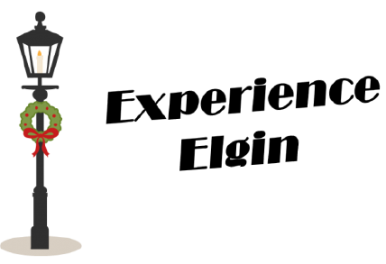

Guidelines
The Experience Elgin Committee invites Elgin area individuals, businesses, or clubs to help decorate Main Street for the holidays AND to raise money for the city to purchase decorations in the future. In the spirit of the season, we wish to make our town festive and welcoming.

- Decorations must be “family friendly” and non-political. Decisions regarding appropriateness are at the discretion of the Experience Elgin Committee.
- Light poles may be decorated to a height of 10 feet from the ground.
- Two outlets available on each pole.
- Existing banner frames may be used.
- Poles may be wrapped with lights or garlands etc.
- Use wire or string to attach decorations to the pole. NO tape is to be used.
- The city will put up their lights above the 10-foot height.
- Complete entry form by Nov 22nd and return to City Hall with the Entry Fee.
Entry fee of $100 for businesses and $50 for all others.
Select the pole you wish to decorate (a map will be provided at City Hall).
- Displays assembled between Nov 29 and Dec. 8.
- Displays to be removed by January 12.

Awards will be presented at the December 14th Selfies with Santa Celebration at the BlackTop Bar and Grill. Winners will be announced at 12:00 noon for 1st and 2nd places in both the business and non-business categories. The first-place business winner will also be awarded the Traveling Santa.

Judging Criteria

Entries will be judge based on
- Overall Appearance - Does it stand out and grab the attention of the public driving by?
- Originality (use of color and structure)
- Construction Quality
- Extra Points - Awarded for: Moveable parts, clever themes, or gimmicks
Judging of entries will be done between Dec. 9 and 13 by a panel of three local judges.

